



**Module Code & Module Title**

**CC4057NT Introduction to Information Systems**

**Assessment Weightage & Type**

**30% Individual Coursework**

**Year and Semester**

**2021-22 Autumn 2**

**Student Name: Geenesh Acharya**

**Group: L1C1 S2**

**London Met ID:**

**College ID:**[**NP05CP4S220023@iic.edu.np**](mailto:NP05CP4S220023@iic.edu.np)

**Assignment Due Date: 1st July 2020**

**Assignment Submission Date: 1st July 2022**

*I confirm that I understand my coursework needs to be submitted online via Google Classroom under the relevant module page before the deadline in order for my assignment to be accepted and marked. I am  fully aware that late submissions will be treated as non-submission and a marks of zero will be awarded.*

Contents

1. Introduction 1

1.1 Website 1

1.2 Webpage 1

1.3 HTML 2

1.4 CSS 3

i. CSS Inline 3

ii. Internal CSS 4

iii. External CSS 4

1.5 JavaScript 5

1.6 Goals and Objectives 5

1.7 Discussion and Analysis 6

1. Text Editor 6

1.8 Tools used for this project 6

I. Balsamiq 6

II. Visual Code Display 6

III. Microsoft word 6

2. Webpages 2.1 Home page 7

• Wireframe of the home page 7

• Screenshot of Home page 8

2.3 Product page 9

2.4 Blog page 11

2.5 Research Page 14

2.6 Contact Page 17

2.7 Login page 19

3. Testing 20

3.1 JavaScript Local Time 20

3.2 JavaScript to Image Slider 21

3.3 JavaScript to Pop-up message 22

3.4 JavaScript to check hover effect 24

3.5 JavaScript to check button 25

4. Conclusion 27

**List of Figures**

**Figure 1 Appearance of HTML (KindPNG, 2019)** 2

**Figure 2 Appearance of CSS (Hafi, 2018)** 3

**Figure 3 Appearance of JavaScript (Free Course for Everyone, 2021)** 5

**Figure 4 Wireframe of home page** 7

# 

# Introduction

## Website

A website comprises several web pages, each of which is a digital file written in HTML (Hyper Text Markup Language). To make your website accessible worldwide, it must be saved or hosted on a computer that is always linked to the Internet. A Web Server is a computer that performs these functions. The website's web pages are connected via hyperlinks and hypertext, and they all have the same look and feel. Additional papers and resources, such as photographs, movies, or other digital assets, may be found. (GeeksforGeeks, 2021)

In response to the coursework question, I created an e-commerce website for a store that sells various mobile phones.

## Webpage

A web page, also known as a website, is a document accessed in an Internet browser and is usually authored in HTML. A URL address may be entered into a browser's address bar to view a web page. Text, pictures, and linkages to other websites and files can all be found on a web page. A web page is frequently used to provide users with information, including images or videos, to highlight essential themes. A web page may also offer items or services to website visitors. (Computer Hope, 2021)

I've constructed a website with five separate pages in response to the coursework's question. I created a home page, also known as an index page, that has a see more button that takes us straight to the product page, where we can see a variety of phones with their reasonable prices and specifications. In a similar vein, I created a blog page where I wrote on the influence of technology, both positive and harmful. Following that is the research page, where I have written about the website from which I have drawn reference, and finally, the contact and login page, where customers may directly contact us.

## HTML

The term HTML stands for Hypertext Markup Language. HTML is a markup language used to produce electronic texts (called pages) displayed on the Internet. Each page has several hyperlinks linked to other sites. Every web page you view was created using a single HTML version. HTML coding guarantees that text and pictures in your browser are formatted correctly. A browser would not be able to display text as elements or load pictures or other components without HTML. HTML also supplies the page's fundamental structure, covered with Cascading Style Sheets to customise its appearance. HTML is like a web page’s bones (structure), and CSS is like the skin (appearance). (Computer Hope, 2021)

The website was built using HTML, CSS, and JavaScript in addition to the goals and objectives established. For the creation of this website, HTML was utilized as a framework. HTML is illustrated below:

<!DOCTYPE html>

<html lang= "English">

<head>

    <title><HTML</title>

</head>

<body>

    <H1>Heading</H1><BR>

        <p> Hello, it’s me Geenesh</P>

</body>

</html>

**Figure 1 Appearance of HTML (KindPNG, 2019)**

## CSS

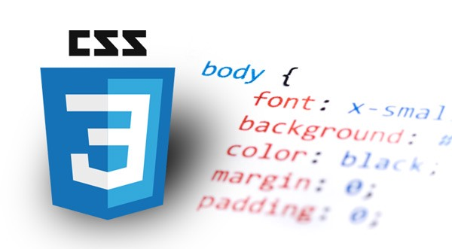CSS stands for cascading style sheets, and it's a language for describing reusable styles for presenting markup texts. The W3C made CSS a specification, allowing web developers to change the layout and look of their websites. CSS may modify the font, size, and color of a specific HTML element. A developer may link a single CSS file to numerous pages, allowing them to update the appearance of all of them at the same time. (Computer Hope, 2019)

**Figure 2 Appearance of CSS (Hafi, 2018)**

In our web pages, we've applied three different types of CSS:

### CSS Inline

Inline CSS is a CSS property in the body section that gives a single element a distinct style. It makes use of an HTML element's style property. As an example,

<!DOCTYPE html>

<html>

<body>

<h1 style="color: blue;">A Blue Heading</h1>

<p style="color: red;">A red paragraph. </p>

</body>

</html>

### Internal CSS

Internal or embedded CSS that uses the <Style> element to include CSS properties in the head section. As an illustration:

<html>

<head>

<title>Internal CSS</title>

    <style>

        h1{

        color: red;

        }

    </style>

<body>

</body>

</html>

### External CSS

External CSS is a separate text file with the.css extension referenced in the head tag, which includes all CSS files using the link tag. To integrate external CSS, for example,

<!DOCTYPE html>

<html lang="en">

<head>

    <title> Online Mobile Store</title>

    <!-- bootstrap for good looks to webpage -->

    <link rel="stylesheet" href="https://cdn.jsdelivr.net/npm/bootstrap@4.3.1/dist/css/bootstrap.min.css">

</head>

<body>

</body>

</html>

## JavaScript

JavaScript is an interpreted client-side scripting language that enables web designers to include code in their pages. JavaScript is the most used programming language today, and it is typically embedded in an HTML or ASP file and runs immediately from the web page. More complex operations, such as displaying the time and date, building a calendar, and other things not achievable with HTML, may be accomplished with JavaScript. (Computer Hope, 2020)

**Figure 3 Appearance of JavaScript (Free Course for Everyone, 2021)**

## Goals and Objectives

The fundamental purpose of this project is to design and develop an e-commerce website with the primary goal of reaching as many people as possible at the right moment to improve sales and profitability. Some objectives of E-commerce are:

1. Reduce the cost of the product by delivering it at the current market rate.
2. To create brand recognition and company identity.
3. To keep track of information about shopping, the payments, bills, and customers.

## Discussion and Analysis

### Text Editor

A text editor is a simple computer tool that lets you create, modify, and edit plain text files. It may be used to make computer programs, edit programming language source code, change hypertext markup language (HTML) and create web pages or design templates. This software is now mainly used for programming rather than document creation, as it was previously. A text editor accepts plain text, not the prepared content found in a rich text editor or word processor. Special capabilities like bold, italic, and varied text sizes and fonts are available in these apps. Word processors add special formatting characters that are not visible in the document, whereas editors display just the characters visible in the file. A system that solely takes plain text does not allow the user to format the text or add images or tables. (Ausbrooks, 2022)

## Tools used for this project

### Balsamiq

Balsamiq Wireframes is a user interface design tool for making wireframes. We may use it to create digital sketches of your idea or concept for an application or website to help with conversation and comprehension before writing any code. The finished wireframes may be used for user testing, defining your vision, gathering feedback from stakeholders, and obtaining clearance to begin development. (Balsamiq, 2022)

### Visual Code Display

Microsoft's Visual Studio Code (VS Code) is a free, open-source text editor. For Windows, Linux, and macOS, VS Code is available. VS Code contains numerous significant features that have made it one of the most popular development environment tools. (Mustafeez, 2022)

### Microsoft word

Microsoft Word is a word processor that was developed by the company Microsoft. It was initially released in 1983, and Charles Simonyi and Richard Brodie created it. You may use Microsoft Word to produce professional-looking documents, reports, letters, and resumes. (Computer Hope, 2021)

# **Webpages**

# **Home page**

There is a header, a navigation bar with a fixed location, a body section, and a footer on the home page. The header, navigation bar, and footer are dark blue, whereas the rest of the site is sky blue.

There are four enormous images of mobile phones in a bootstrap slide show, each with a different slogan for the mobile store. There is a see more product button underneath the image that takes you to the following page, which is the product.

Then there's a footer with three social media icons that connect with customers and provide them with information about our shop. In addition, we have three other pages: about us, privacy policy, and terms of service. As a result, I've positioned myself as a web designer. Then there's copyright information and local time, both of which are generated using JavaScript.

The index.html file is used to save the home page.

* 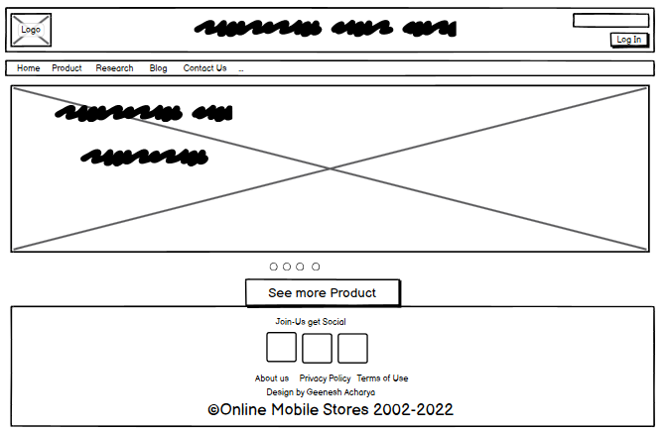Wireframe of the home page

**Figure 4 Wireframe of home page**

* 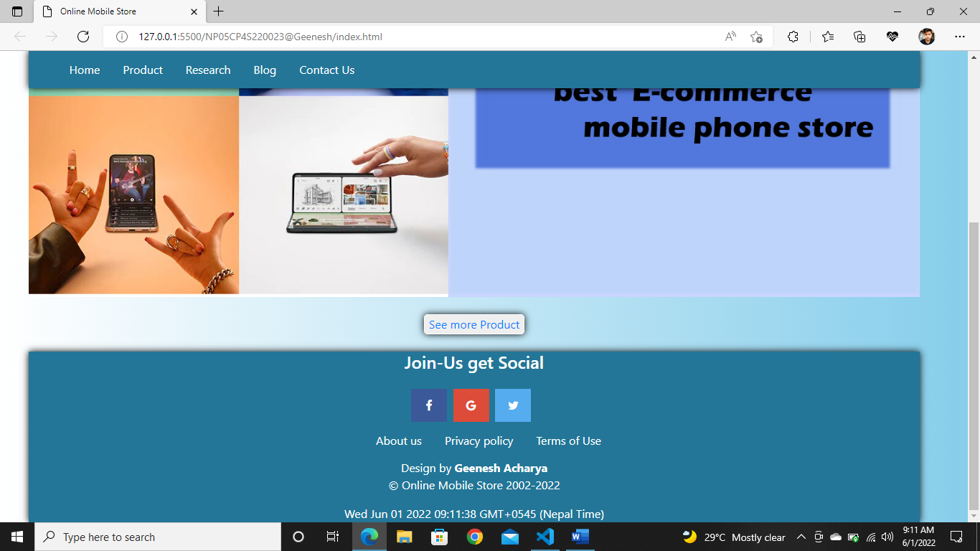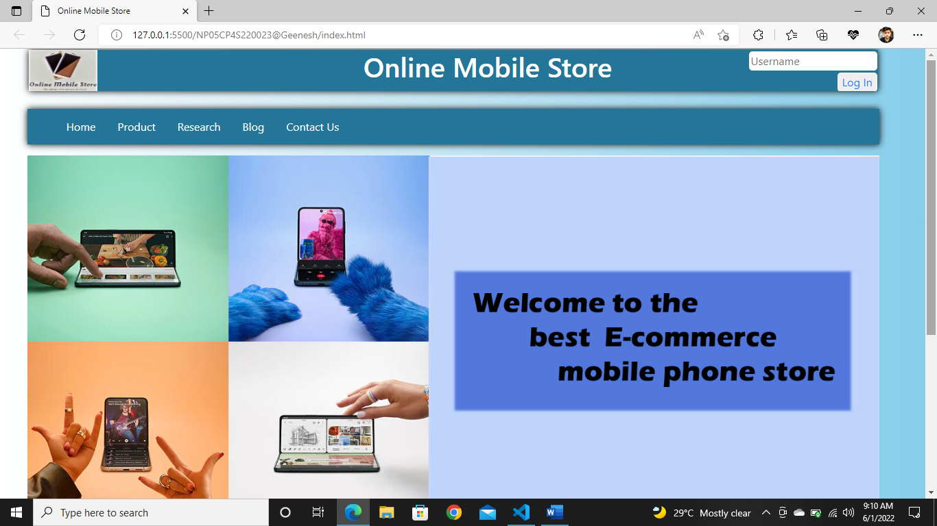**Screenshot of Home page**

**Figure 5 Screenshot of Home page**

## Product page

The product page has the same header, navigation bar, and features as the previous pages.

The content is presented in large, strong letters. This informs the user about the current page. Then there are several mobile phones from various companies, each with its brand and price. Every mobile has a purchase now and sees a specs button that takes the client directly to our contact us webpage.

It's the same for the footer for the home page. The name of the product page is Products.html.

* 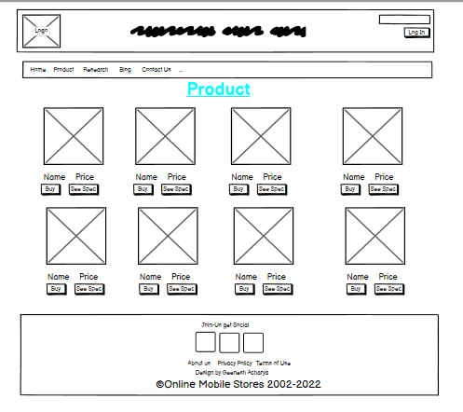**Wireframe of the Product page**

**Figure 6 Wireframe of Product page**

* 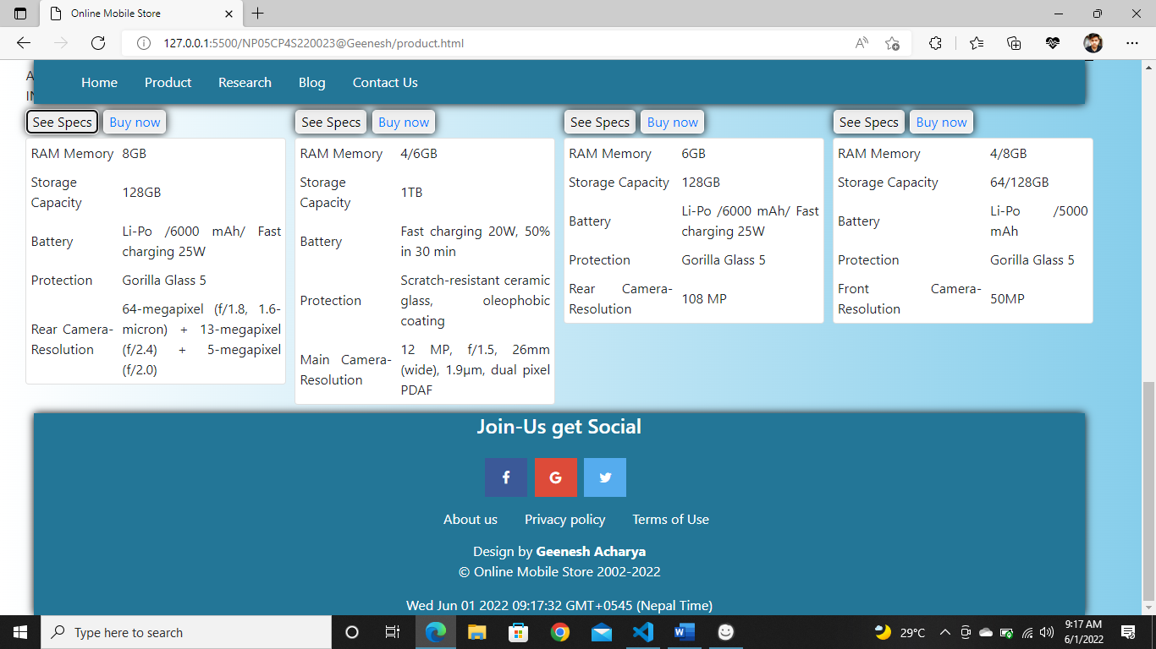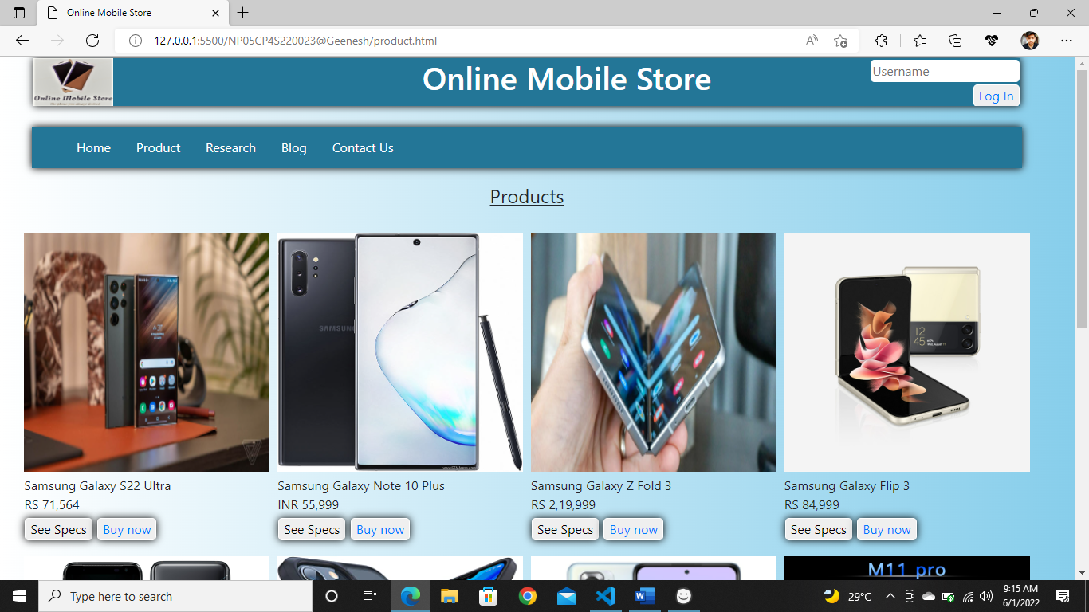**Screenshot of the Product page**

**Figure 7 Screenshot of Product page**

## Blog page

This page has the same navigation bar and footer with the same features as the previous page.

On the left side of the blog page, there is an appearance of the impact of technology, which also informs the user about the issue. Then there's an explanation on the right side of the photo, and underneath the photo and text, I've included some bullet points and an explanation. The information was gathered from several websites.

This page's name is preserved as blog.html.

* 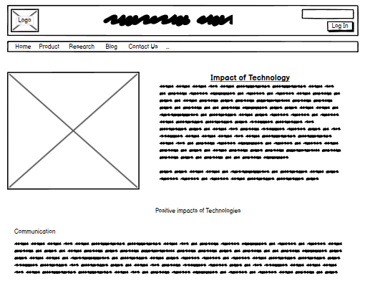**Wireframe of the Blog page**
* 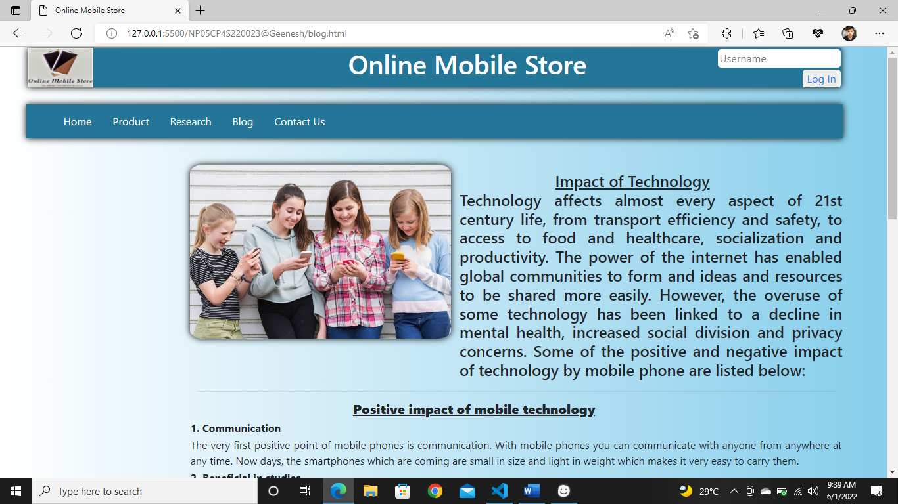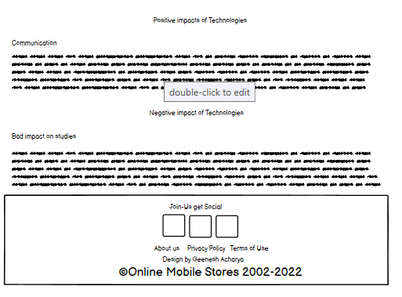**Screenshot of the Blog page**

**Figure 8 Wireframe of Blog page**

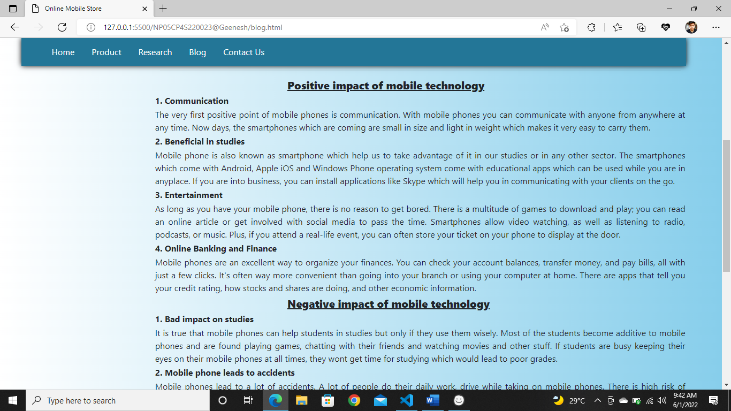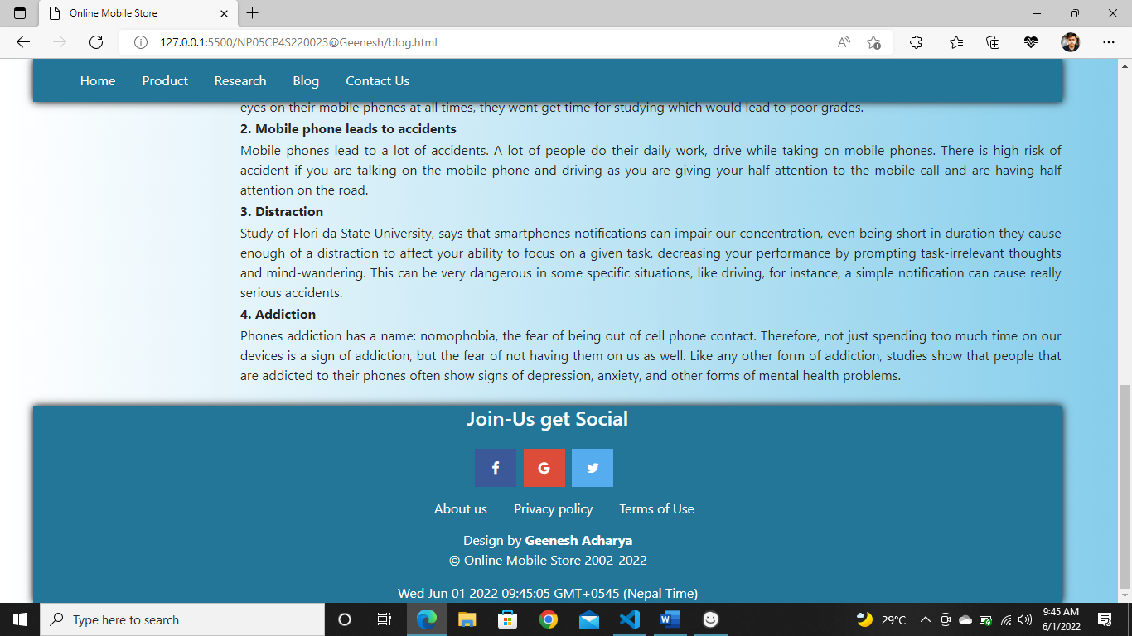

**Figure 9 Screenshot of Blog page**

## Research Page

The navigation bar and footer remain the same on this page with the logo.

On the left side of the Research page, there is an appearance of several websites from which I have taken inspiration to create my e-commerce mobile store. Then, on the right side of the shot, there's a description of what I admire most. The data was taken from several websites.

The file is saved with the name: research.html.

* 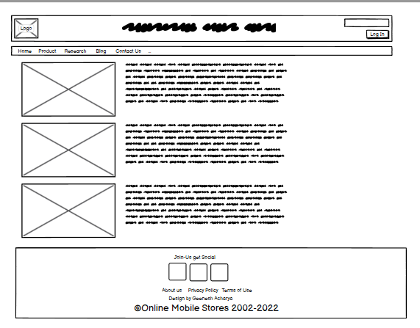**Wireframe of Research page**

**Figure 10 Wireframe of Research page**

* 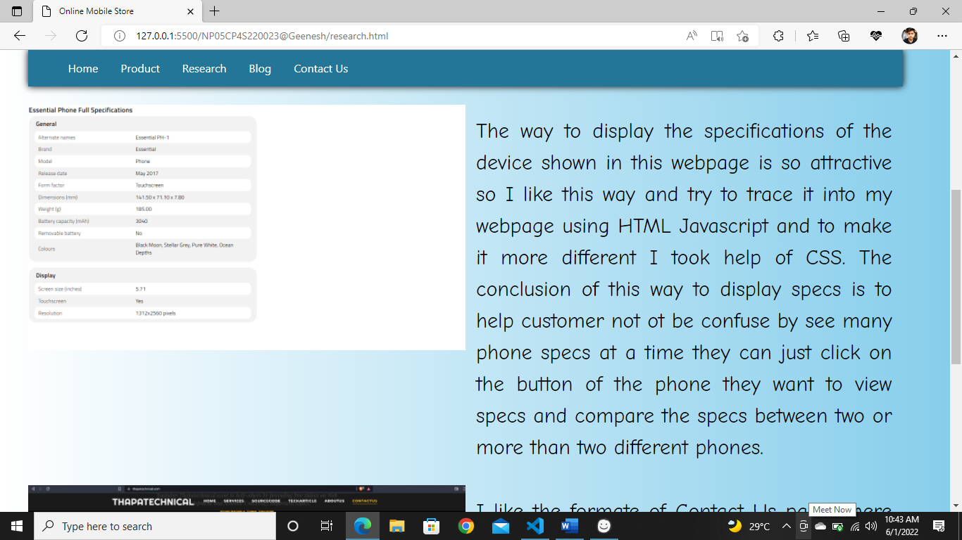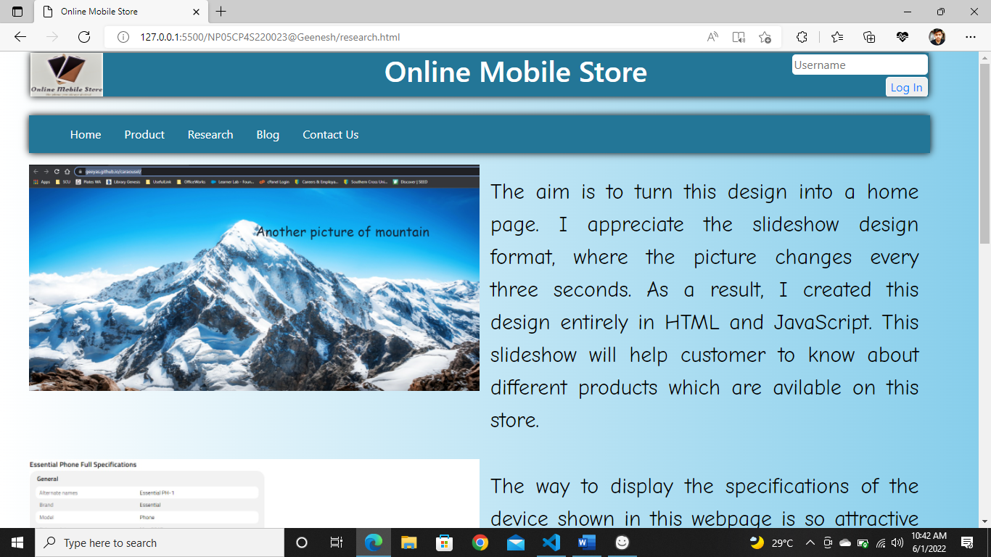**Screenshot of Research page**

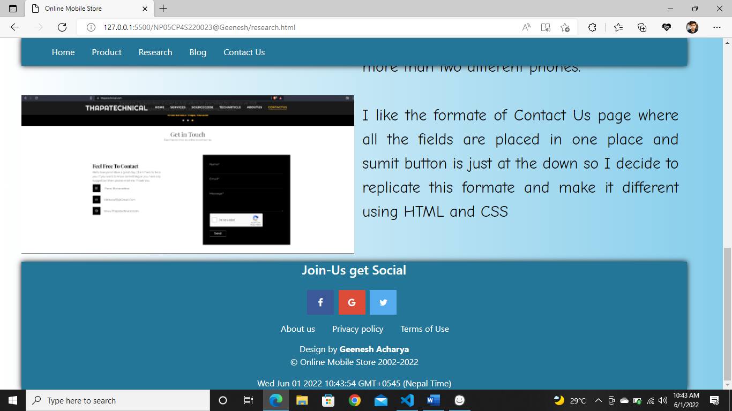

**Figure 11 Screenshot of Research page**

## Contact Page

The navigation bar and footer, as well as the logo, are the same on this page.

The contact page was then given a prominent header in the middle. The first name, last name, location, and email section are the four input areas providing detailed information about the consumer. Then, in case of an empty area, I utilized JavaScript to pop up a message, and finally, there is a send button with the proper message.

Contact.html is the name given to the file.

* 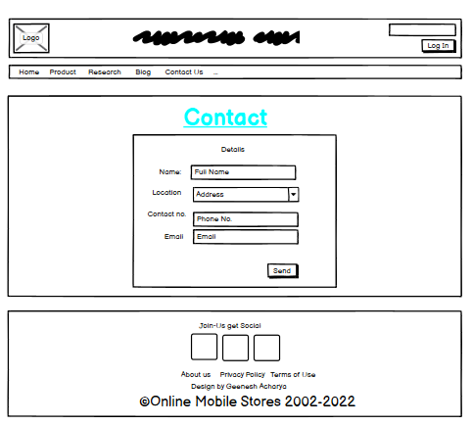**Wireframe of Contact page**

**Figure 12 Wireframe of Contact page**

* 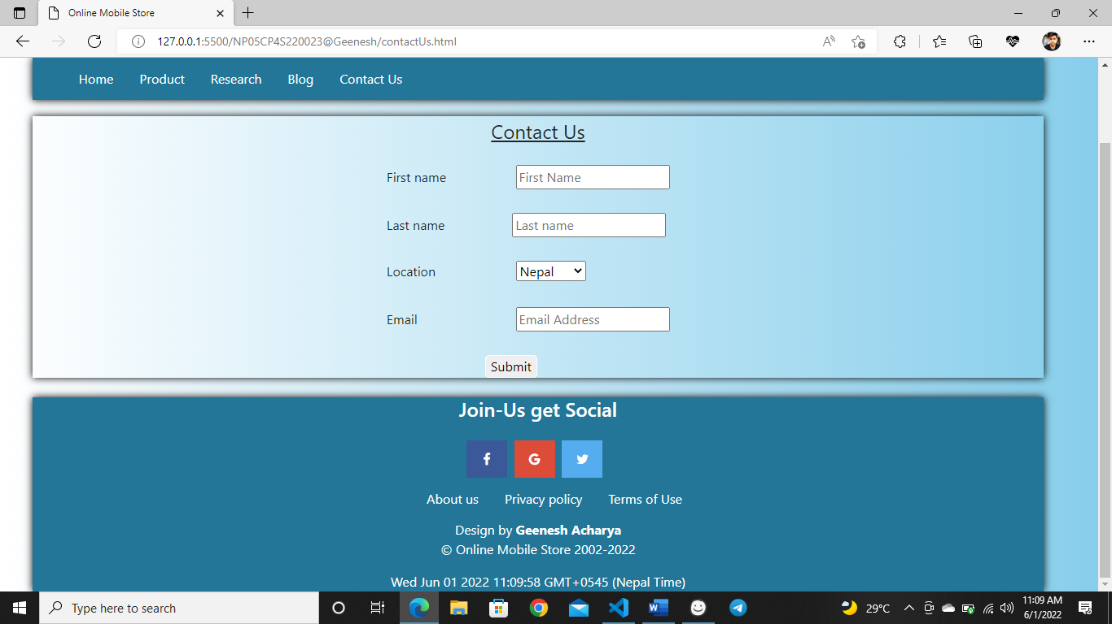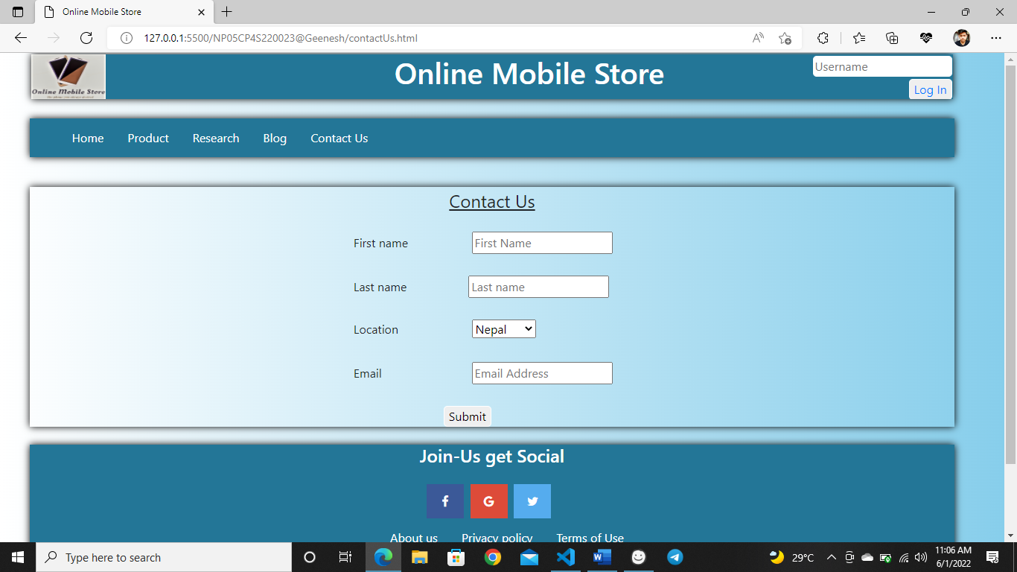**Screenshot of Contact page**

**Figure 13 Screenshot of Contact us page**

## Login page

The navigation bar and footer, as well as the logo, are the same on this page.

The Login page was then given a prominent header in the middle. The username and Password section are the two input areas providing detailed information about the consumer. Below the section you can save details for another login by clicking on keep login.

login.html is the name given to the file.

* 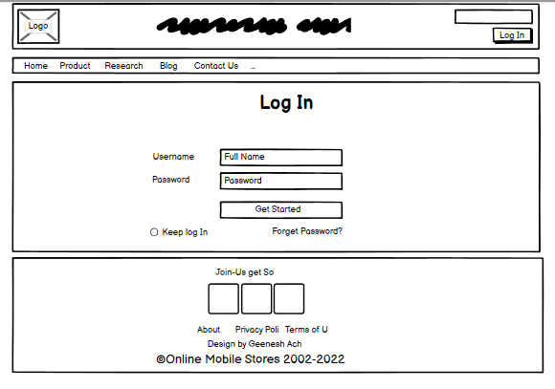**Wireframe of Login page**

**Figure 14 Wireframe of Login page**

* 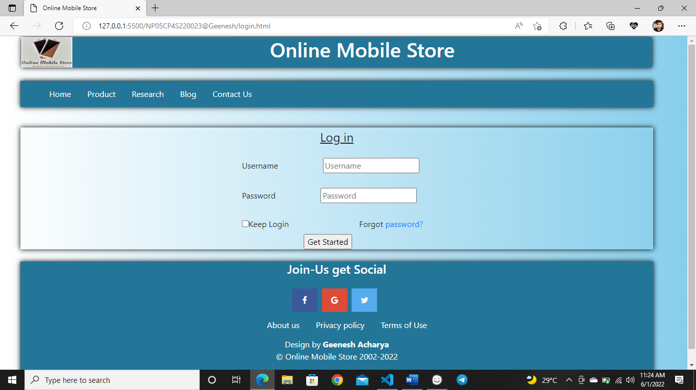**Screenshot of Log In page**

**Figure 15 Screenshot of Log In page**

# Testing

## JavaScript Local Time

|  |  |
| --- | --- |
| **Objective** | **To display the current time in the given location.** |
| **Action** | **To display the local time every second.** |
| **Expected Result** | **It should display the local time every second.** |
| **Actual Result** | **It displayed the local time every second.** |
| **Test** | **Successful** |

**Table 1 Testing the JavaScript of local time.**



**Figure 16 Screenshot of testing local time**

## JavaScript to Image Slider

|  |  |
| --- | --- |
| **Objective** | **To change the image every 3 seconds.** |
| **Action** | **Every 3 seconds, the picture should change.** |
| **Expected Result** | **The picture should be changed every 3 seconds.** |
| **Actual Result** | **The picture was updated every 3 seconds.** |
| **Test** | **Successful** |

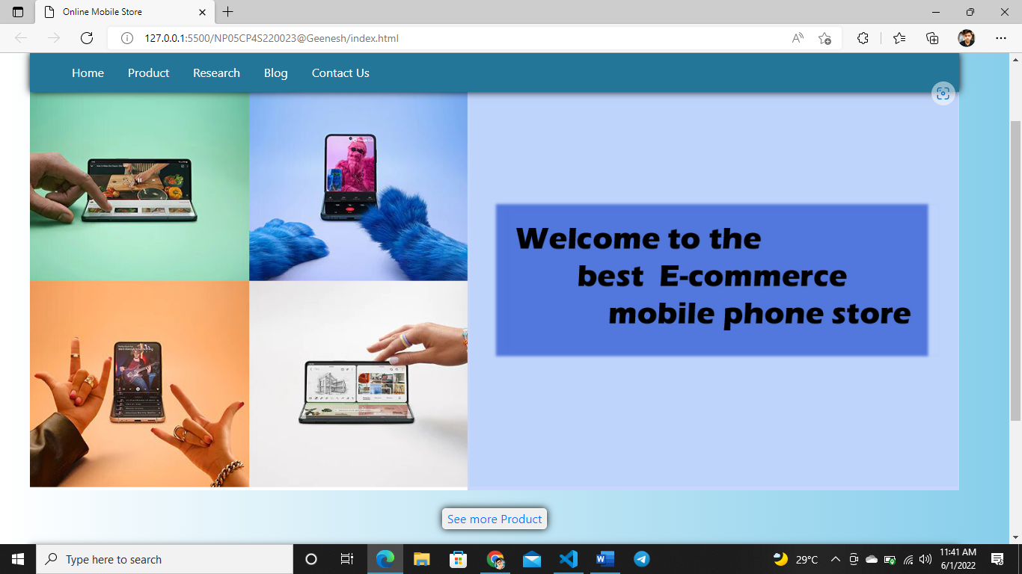**Table 2 Testing the JavaScript of Image Slider**

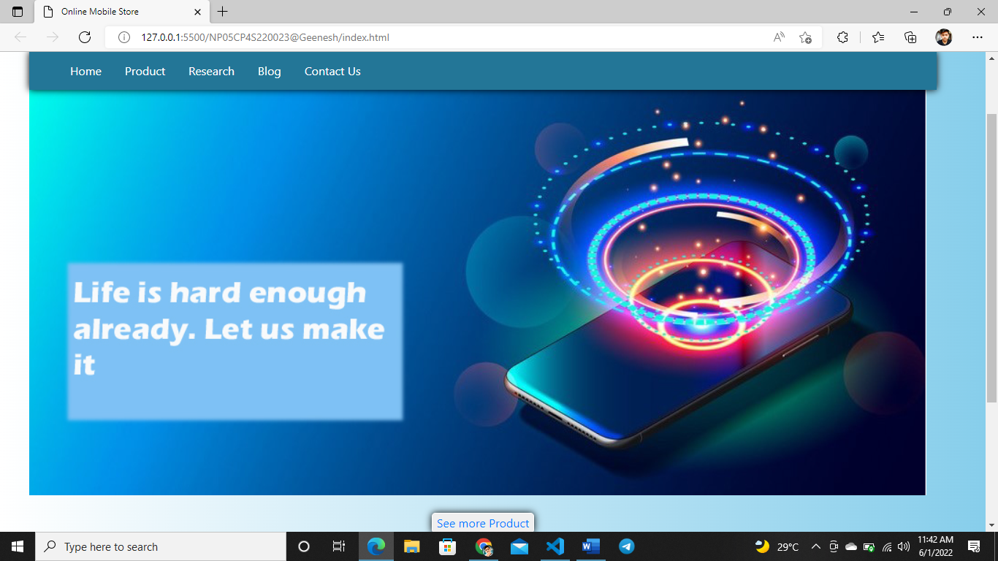

**Figure 17 Screenshot of testing Image slider**

## JavaScript to Pop-up message

|  |  |
| --- | --- |
| **Objective** | **To send a Pop-up message** |
| **Action** | **There should be a pop-up message when the readers send the form.** |
| **Expected Result** | **When all of the fields have been filled out and submitted, the following message should appear:**  **“Thank for you interest. One of our friendly team members will be in touch with you shortly.”**  **When one or more fields are not completed and submitted, the following notice should appear:**  **“Fill in your Last Name”** |
| **Actual Result** | **When the form was completed and submitted, a popup notification appeared that read:**  **“Thank for you interest. One of our friendly team members will be in touch with you shortly.”**  **A pop-up notice appeared if any one or more fields were not filled and submitted:**  **“Fill in your Last Name”** |
| **Test** | **Successful** |

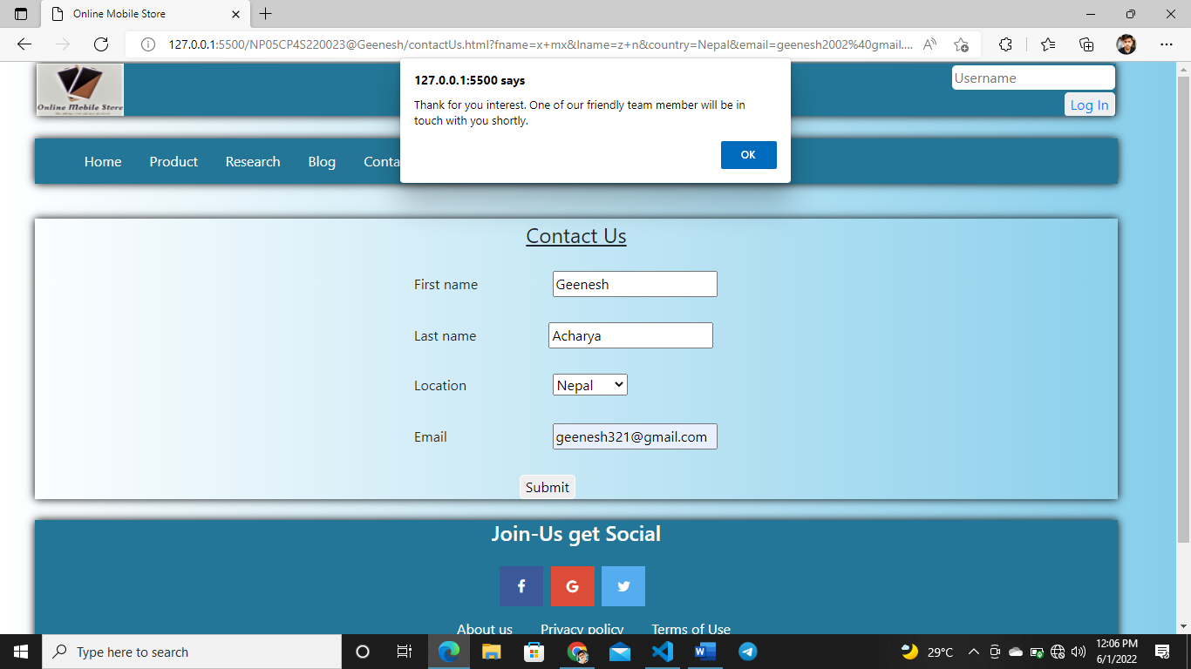**Table 3 Testing the JavaScript to pop-up message**

**Figure 18 Screenshot of testing When all the fields are filled and submitted**

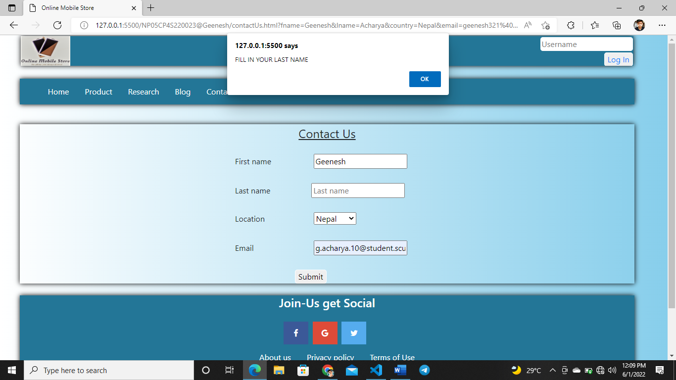

**Figure 19 Screenshot of testing When any one or more fields were not filled.**

## JavaScript to check hover effect

|  |  |
| --- | --- |
| **Objective** | **To check the hover effect works or not.** |
| **Action** | **Hover when the pointer moves on products.** |
| **Expected Result** | **When we hover over the objects, the color or text should change.** |
| **Actual Result** | **When the product's items are hovered, the color changes.** |
| **Test** | **Successful** |

**Table 4 Testing the JavaScript to hover effect**

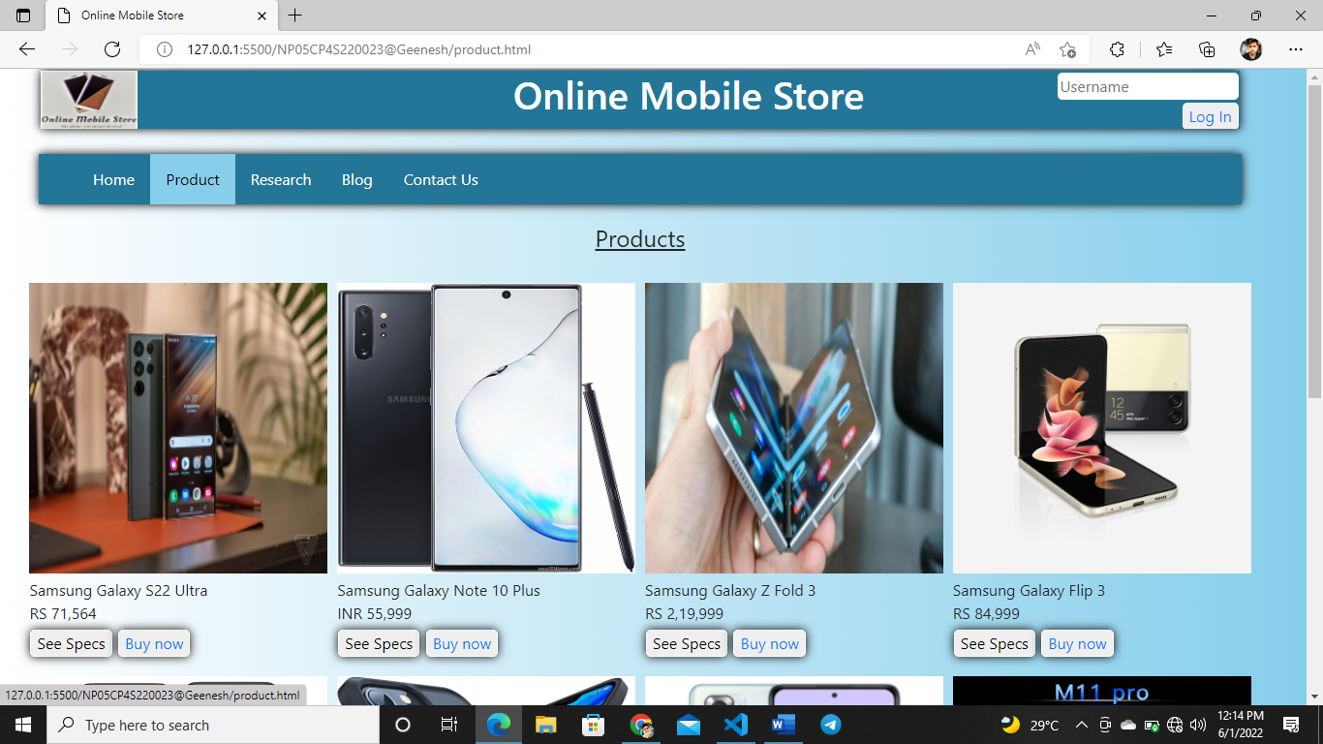

**Figure 20 Screenshot of testing to hover effect**

## JavaScript to check button

|  |  |
| --- | --- |
| **Objective** | **To check whether the button is working or not.** |
| **Action** | **Click the buttons of the web pages.** |
| **Expected Result** | **Customers should be able to engage with other pages when they click on buttons.** |
| **Actual Result** | **The user is taken to the product page when they click the Shop Now button.** |
| **Test** | **Successful** |

Table Testing the JavaScript to button

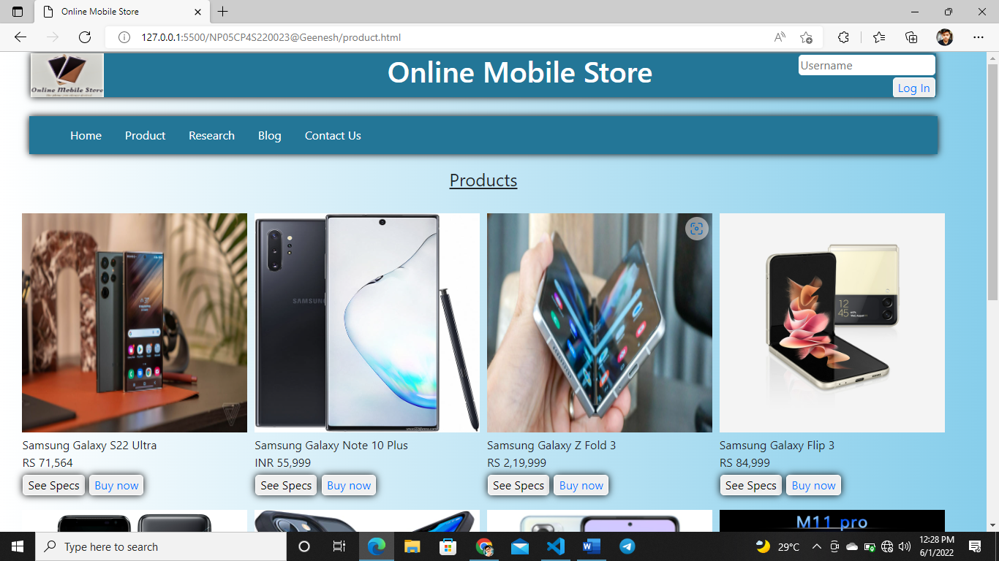 **Figure 22 Screenshot of testing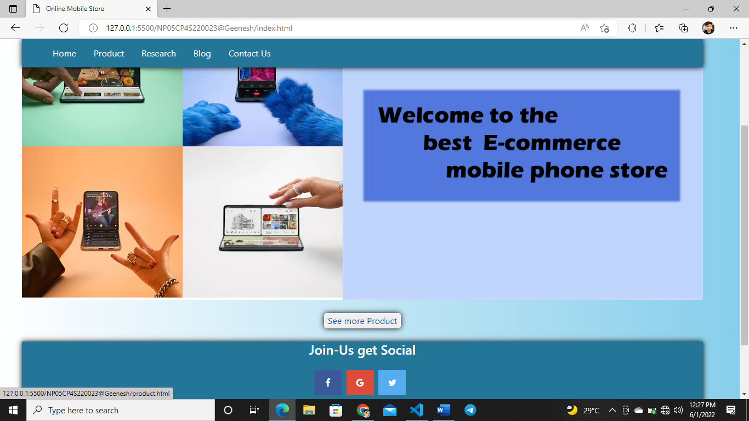 button work properly**

**Figure 21 Clicking on See more product button**

# Conclusion

Last but not least, I concluded that in today's society, everyone wants to be a competent programmer or web developer. Still, to do so, we need to study and comprehend various languages such as JavaScript, HTML, CSS, and Python, among others. I was a little worried and scared before I started the coursework. The curriculum focused on creating an e-commerce website for a mobile phone store.

This course work focuses on webpage building using HTML, CSS, and JavaScript. I created an e-commerce website for a store that sells various mobile phones, allowing users to purchase products by looking at the accurate pricing of the phone and the business name and other information. Customers might enjoy advantages such as faster delivery and the convenience of buying from the comfort of their own homes." I created wireframes for websites and began developing a website as part of my assignment. I built a website with five pages, each with a header, login, navigation, and footer, among other things.

There are various phones on the product page, each with a reasonable price and detailed specifications and a buy now button allows customers to purchase and go to the login page quickly. Customer after logging in. After logging in, customers are sent to a contact page where they must fill out a form with information such as their address, email address for verification, etc. In response to the query, there is a blog on the influence of technology, both positive and bad aspects, on the blog page. I provided a source from which I conducted a study to create the project's design on the research page.

Furthermore, I have had various difficulties when coding. Still, it has been simpler to comprehend due to the support of reputable teachers and my brother, who has greatly aided me in completing this homework. Finally, our mobile phones are our most personal devices, and we should optimize their use.